**Задание на защиту**

Диаграмма отношений сущность:

Рис. 1

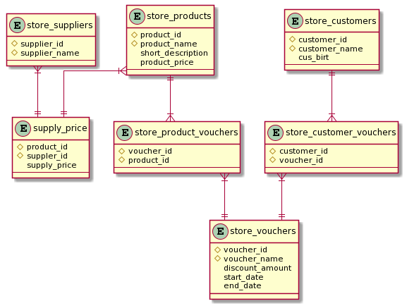

Ссылка на приложения:

<https://github.com/ThuyHienDo/Oracle-SQL/blob/main/lab1-2/lab1-2new.txt>

1. Что значит ROWS BETWEEN UNBOUNDED PRECEDING AND CURRENT ROW?

UNBOUNDED PRECEDING – все предыдущие записи

CURRENT ROW – отображение текущей строки

ROWS BETWEEN UNBOUNDED PRECEDING AND CURRENT ROW значит ограничение по всем предыдущим строкам и текущей.

2. Выведите для каждого клиента (customer_name):

а. Скидку в процентах по самому лучшему из купонов, действующих на в данный момент:

SELECT store_customers.cus_n,

2 MAX(store_vouchers.discount_amount) as highest_discount

3 FROM store_customers

4 INNER JOIN store_customer_vouchers ON store_customer_vouchers.customer_id=store_customers.customer_id

5 INNER JOIN store_vouchers ON store_vouchers.voucher_id=store_customer_vouchers.voucher_id

6 WHERE store_vouchers.start_date = '01-MAY-21'

7 GROUP BY store_customers.cus_n;

б. Общее колическтво действующих купонов у него на руках:

SELECT store_customers.cus_n,

2 COUNT(store_customer_vouchers.voucher_id) as NUM_OF_VOUCHERs

3 FROM store_customers

4 INNER JOIN store_customer_vouchers ON store_customer_vouchers.customer_id=store_customers.customer_id

5 INNER JOIN store_vouchers ON store_vouchers.voucher_id=store_customer_vouchers.voucher_id

6 GROUP BY store_customers.cus_n;

в. Стоимость самого дорогого товара с учётом скидки по купону:

Здесь получить стоимость самого дорогого товара с учётом скидки в процентах по самому лучшему из купонов, которые есть у каждого покупателя. Каждый купон можно использовать только с определенными продуктами.

WITH t1 AS (SELECT store_customers.cus_n,

2 (MAX(store_products.product_price)-(MAX(store_vouchers.discount_amount)*MAX(store_products.product_price))) as w_dis,

3 MAX(store_products.product_price) as org_pr

4 FROM store_customers

5 INNER JOIN store_customer_vouchers ON store_customer_vouchers.customer_id=store_customers.customer_id

6 INNER JOIN store_vouchers ON store_vouchers.voucher_id=store_customer_vouchers.voucher_id

7 INNER JOIN store_product_vouchers ON store_product_vouchers.voucher_id=store_vouchers.voucher_id

8 INNER JOIN store_products ON store_products.product_id=store_product_vouchers.product_id

9 GROUP BY store_customers.cus_n),

10 t3 AS (SELECT product_name,product_price FROM store_products)

11 SELECT t1.cus_n,t3.product_name,t1.w_dis

12 FROM t1 INNER JOIN t3 ON t1.org_pr=t3.product_price;

г. Разность между ценой с учётом скидки и полной ценой.

WITH t1 AS (SELECT store_customers.cus_n,

2 (MAX(store_products.product_price)-(MAX(store_vouchers.discount_amount)*MAX(store_products.product_price))) as w_dis

3 FROM store_customers

4 INNER JOIN store_customer_vouchers ON store_customer_vouchers.customer_id=store_customers.customer_id

5 INNER JOIN store_vouchers ON store_vouchers.voucher_id=store_customer_vouchers.voucher_id

6 INNER JOIN store_product_vouchers ON store_product_vouchers.voucher_id=store_vouchers.voucher_id

7 INNER JOIN store_products ON store_products.product_id=store_product_vouchers.product_id

8 GROUP BY store_customers.cus_n),

9 t2 AS (SELECT store_customers.cus_n,

10 MAX(store_products.product_price) as org_pr

11 FROM store_customers

12 INNER JOIN store_customer_vouchers ON store_customer_vouchers.customer_id=store_customers.customer_id

13 INNER JOIN store_vouchers ON store_vouchers.voucher_id=store_customer_vouchers.voucher_id

14 INNER JOIN store_product_vouchers ON store_product_vouchers.voucher_id=store_vouchers.voucher_id

15 INNER JOIN store_products ON store_products.product_id=store_product_vouchers.product_id

16 GROUP BY store_customers.cus_n),

17 t3 AS (SELECT product_name,product_price FROM store_products)

18 SELECT t1.cus_n,t3.product_name,t1.w_dis,t2.org_pr,

19 (t2.org_pr-t1.w_dis) as diff

20 FROM t1

21 INNER JOIN t2 ON t1.cus_n=t2.cus_n

22 INNER JOIN t3 ON t2.org_pr=t3.product_price;